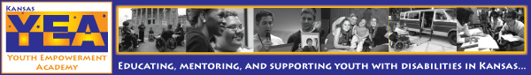
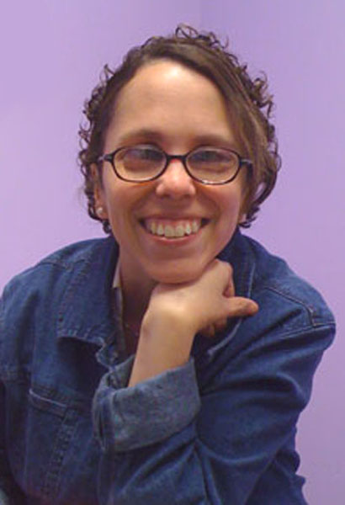
Kansas Youth Empowerment Academy Newsletter Nov 2011
As we gear up for the colder months, fall is a reminder that not everything lasts. Trees are changing, animals are going into hibernation, and everyone is beginning to settle into the stressful holiday months.

But KYEA couldn't wait until spring to bring back our newsletter! Here in the KYEA offices, there are birds singing, flowers blooming, and baby bunnies hopping. Okay, maybe not, but it's a metaphor, go with it!

We see every bump along the road as a new challenge and, as always, we are rising to meet it! As you may have heard, the Kansas Youth Empowerment Academy is in a dire fundraising crisis. We don't know if our doors will stay open past December. But KYEA refuses to give up! We are tirelessly working to make sure that this does not happen. YOU play such an important role in keeping our doors open!

Please show your support for youth with disabilities by donating to KYEA today. You can donate directly by mail or by visiting our website. We hope you will enjoy the return of our newsletter, full of local updates, national news, and even more about the amazing things youth with disabilities are doing in Kansas.

Behind Julia’s Glasses
By Julia Thomas, Executive Director

As the Halloween tricks and treats have passed and we are moving closer to
Thanksgiving, I begin to prepare myself for a piece of humble pie. Prior to
this year, my favorite pie was sweet potato, but some experiences have added
this new pie to the number 1 slot. As a child, I remember holidays in which we
had an abundance of family members around and gifts to please all and I also
remember the holidays where it was just my parents and I (as the youngest sibling),
and having no gifts to share. As a child, not receiving gifts was a big downer.
Beginning in my teenage years though, I began to see and appreciate the value
of relationships and positive support as the greatest gifts of all.

This past June, I was reminded of my childhood holidays experiences when KYEA was informed of some budget cuts we would be experiencing. After freaking out for a moment, KYEA staff rallied around and developed an intensive fundraising plan through the end of December. With the real possibility of shutting our doors as of January 1st, staff proceeded forward with a pit bull dog passion of raising money and doing everything possible to keep our doors open if for only one extra month. The out poor of support from our young adult alumni, independent living community and long time followers was simply amazing! Pieces of humble pie slices include:
- The outpour of donations from youth and young adults who have received support from us in the past;
- Donations from individuals who either we have never met or have just had maybe one experience with them;
Behind Julia’s Glasses continued

One specific instance was when we received a phone call in early September from a former personal care attendant from our Kansas Youth Leadership Forum. Hannah had shared with us that her brother John had just passed away a few days prior and her family was setting up a memorial fund in his honor. She remembered reading about our financial hardships as well as remembering what an impact KSYLF made on her and youth with disabilities.

Hannah expressed that her family would like to donate the proceeds from the memorial fund to KYEA in support of the work that we do. Hannah had worked for us ONE WEEK out of ONE Year and we had NEVER even met her brother or family! How could this family be so generous?? We soon realized that not only did the almost $6,000 appear at the most perfect time, but most of all, we were able to learn about Hannah's brother John and his contribution and impact he made while on this earth and even now as he has passed. KYEA now has a wonderful relationship with a family where, out of their grief, they were able to share the joy and legacy of their son John in order to help others! I have to admit, I ate more than one piece of humble pie with this one. :)

Another experience happened just recently. Throughout all of KYEA's programs, we educate youth and young adults on characteristics of leadership and how leadership can look different for everyone. We share how important it is to learn and know yourself and your disability as well as striving for success. Being told that I was a leader in 2003 for the first time scared the heck out of me! I had this impression that leaders had to make all the right decisions and had to demonstrate good judgment at ALL times. Well, throughout the years, I learned that this was not true but for some reason was still holding myself to those outrageous expectations. Do not get me wrong, anyone who knows me KNOWS that I have high expectations of myself and those around me. BUT, there is a difference between high expectations and down right outrageous ones. For example, expecting a leader to never have a moment of bad judgment is outrageous and quite honestly, unrealistic. By having this perception that all my decisions had to be perfect truly set me up for failure.

Experiencing a poor judgment of mine just recently, I felt very embarrassed, alone and began to isolate myself. This did not last too long because a colleague and friend of mine quickly called my bluff and shared how she herself as a leader has made the very same mistake! What I soon realized is that many leaders do make mistakes. The problem is that leaders have trouble sharing those mistakes with others. But once my friend shared with me her mistakes, I immediately felt I was not such a horrible leader after all. Now don't get me wrong, just because I now know others make similar mistakes does not mean it is acceptable for me to continue making the same mistake, but what it does mean is that I now have someone who understands and can help me find tools to not make the same mistake twice.

This piece of humble pie showed me that as leaders we are taught to be role models and examples for others through our successes. However, we cannot forget that by sharing our failures we are helping others to realize that we are all human and not perfect. By sharing our stumbles and taking responsibility for them, we are helping each other become stronger leaders, stronger advocates, and stronger community members! Remember, sharing your success is easy, but sharing your imperfections and stumbles is the true tool we all learn from.

I have to say, even though my belly feels really full of humble pie at the moment, I do not have the will power to turn down a few more pieces! Thanks to all of you that have fed my heart and the hearts of Kansas youth with disabilities!

"I CAN and I WILL" - Julia Thomas, Executive Director

Spotlight on Bullying
By Trey Morgan, KYEA youth intern

The reason I want to talk about bullying in schools is because I myself was bullied relentlessly. I was pushed, shoved, beaten up, verbally and physically tormented. Naturally, school was hell. I had no friends and I was treated as if I was the black plague. I even pretended that the people who were tormenting me were my friends because I was so lonely. Due to the issues that had occurred I had been hospitalized twice at a mental institution. At the institution, I was scared for my life. I didn't feel I belonged there with the others. That's why I want to get rid of bullying I don't want others to experience what I had. I believe that if I tell my story to people they will understand what bullying can do to a child's psyche and they will understand the evil of bullying and change their ways. It also makes the bullied feel like they are not alone.

KYEA Updates

Giving Thanks to Former Director

- In October 2011, KYEA turned one year older and is now on its 6th year of celebrating empowerment! As November reminds us all to be thankful, KYEA would like to wish Brenda Eddy all the very best in her new life and retirement. As many of you know, or may not know, KYEA began as a project under the Resource Center for Independent Living. Through Brenda's hard work and vision, she sought funding, wrote grants and organized statewide support in order that KYEA came into being. Brenda served as Executive Director and the organization flourished under her leadership. We wish her the very best for the future.

- Kansas Youth Leadership Forum searching for potential youth leaders

It's that time again! KYEA is currently searching for potential youth leaders to
attend our 12th Annual Kansas Youth Leadership Forum for Students with
Disabilities (KSYLF). Are you a youth with a disability who has an interest in leadership, who wants to become a better advocate, or who would like to meet other youth leaders with disabilities? Then consider applying to the KSYLF! The 2012 KSYLF will be held June 18-23rd at Washburn University in Topeka.

The KSYLF is a motivational five day forum in which a group of students gather to learn about leadership development and disability pride. During the forum, delegates enjoy a week full of learning, fun, friends, and, most of all, a new sense of empowerment! Through various large sessions, delegates are able to hear from community leaders on such topics as disability history, advocacy, goal setting, leadership, resources, and much more. Students are also able to share life experiences, goals, and ideas during breakout sessions with small groups. Delegates participate in fun activities as well, such as a Day at the Capitol, Mentor Luncheon, adapted recreation, Real Life Affair, and a barbecue. A talent show and dance, which are always delegate favorites, are also a part of the week!

All students who are interested in attending the KSYLF must meet the following criteria: reside in Kansas, have a disability as defined with the Americans With Disabilities Act, be in the 11th or 12th grade as of December 31, 2011, have demonstrated leadership potential in school and the community. Interested students must fill out an application that will be reviewed through a competitive selection process. About 30 - 35 delegates will be selected to attend. Applications can be found on the KSYLF section of the KYEA website at www.kyea.org/ksylf. The application deadline for the 2012 forum is January 15, 2012.

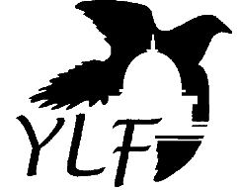

New Faces around KYEA!

Sydney Spyres first started at KYEA this summer as a work study employee through the Bonner Leader program at Washburn University and is now the Outreach Coordinator. She is a sophomore at Washburn studying Social Work. Sydney enjoys movies, reading, all things Harry Potter, and puppies.

Rachel Gadd-Nelson is a recent KU
grad with a Bachelor's of Social
Work. She lives in Lawrence where
she likes to hang out downtown,
play with her cats, and cook and
bake with her friends. Rachel is
excited to work at KYEA because
she loves working with youth and helping them create safe space in their communities, schools and homes! She is KYEA's new Development Coordinator.

Doug Olmstead is KYEA's most recent addition as Administrative Assistant! He is a life-long Topeka resident and graduated from Washburn University. Doug also plays the guitar and loves animals! Welcome, Doug!

YWD Happenings!
The latest good news from
youth with disabilities in Kansas.

Amber is a true example of
accomplishment and growth
as a person. She's a former
KYEA intern and recently
was our temp Administrative
Assistant. But now, she's
moved on to greener
pastures as a teacher
assistant at Susanna Wesley
Preschool in Topeka! Amber also recently received the Young Advocate Award at the 2011 Kansas Disability Caucus. Congrats, Amber!

Nick, KSYLF alum, has always known that he wanted to be a radio broadcaster! He has been working hard at Colby Community College to make this happen and was recently featured on a national radio show Joni and Friends. Now he's going to intern there this coming summer. Way to go, Nick!

Jackie creates handbags
for her very own business
called Jackie K Bags. She
was recognized for her
creative employment by
the Kansas Department of
Commerce. In honor of the
Kansas Minority Enterprise
Development Week, Jackie
received the Young Entrepreneur Award.
She attended a banquet where she will be recognized for her achievements. Congrats, Jackie!

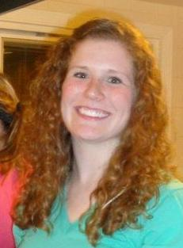
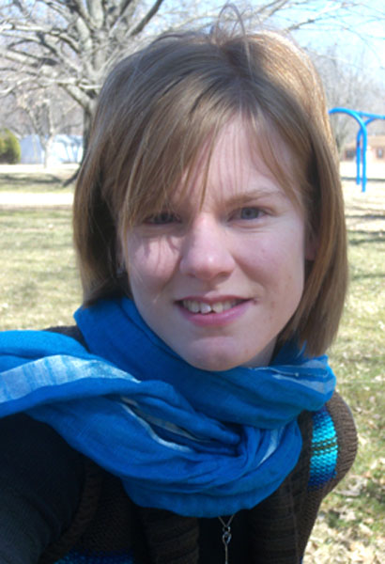

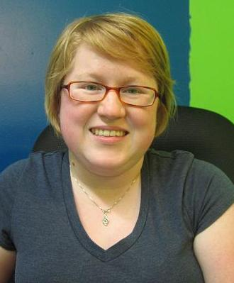

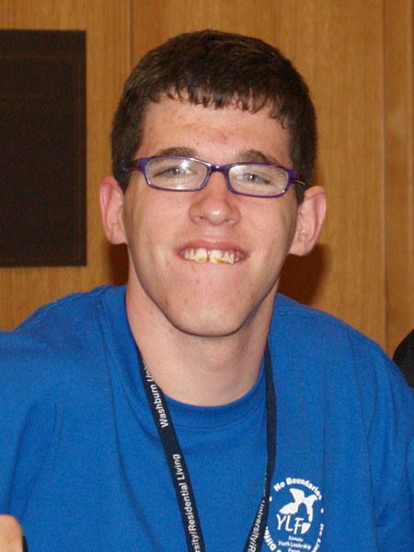



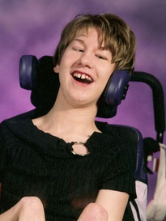

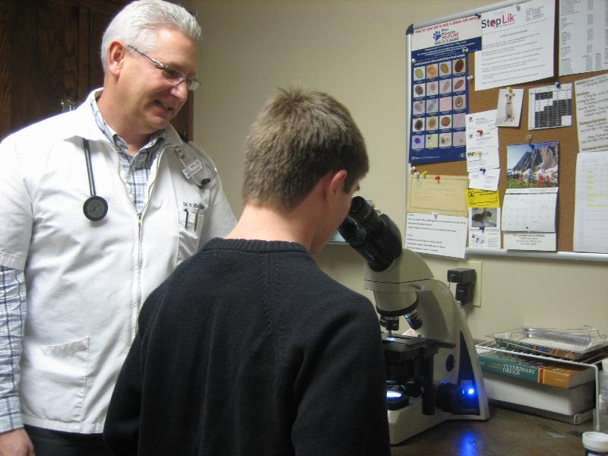

Jesse Fisher, a participant in the 2011 Disability Mentoring Day, did a job shadow at Paw Prints where he got to learn about what veterinarians do. He got to interact with animals, do heartworm tests, and more! Here he's looking through a microscope to examine a tick found on an animal.

KYEA Staff and Ambassador Speakers Available for Community Presentations

KYEA travels the entire state working
to educate Kansans of all ages through
a variety of presentations. Does your
group need some education on any
disability-related topics like disability
awareness or history? Then contact us, and
we've got a speaker for you! Our staff have the
experience, knowledge, and passion to speak on a
variety of topics. We have also been recently
training nine KYEA Ambassadors to go out and
present in their areas of the state. The Ambassadors are youth with disabilities who have an interest in educating the community and public speaking. These youth are in the process of being trained to present a variety of topics, and they will be joining KYEA staff at upcoming presentations.

Remember, KYEA speakers can present to a wide variety of groups. All KYEA presentations are interactive and informative! Each presentation is adjusted to fit the specific audience. Our presentations can be beneficial for people with AND without disabilities, as well as people of all ages. Audiences can include staff trainings, business and civic group meetings, school classrooms, and more.

KYEA speakers can present on the following topics:
- Disability Awareness and Etiquette
- Disability History
- Advocacy
- Self-Esteem
- Goal Setting
- Youth Leadership & Empowerment
- Other Topics: Independent Living, Community Service, Sharing of Personal Stories, etc.

Book your presentation today! For more information on the different presentation, visit our website at kyea.org. To secure a KYEA speaker, contact Carrie at 785-215-6655 or carrieg@kyea.org.
News and Events

- Ms. Wheelchair Kansas Seeking Nominations and Contestants: www.mswheelchairkansas.org
- KDHE Seeking Community Providers to Add to Resource Guide: www.kansasresourceguide.org/resource_directory.htm
- NCIL Announces Policy Internship Program in Washington, DC: www.ncil.org/jobs/ncilinterns11.html
- NCWD/Youth Releases Apprenticeship Workshop Training Materials: http://www.ncwd-youth.info/apprenticeship-workshop-training-modules
- Youth Exchange Scholarship Available for Students to Study in Germany: www.usagermanyscholarship.org
- New Riot Newsletter Issue Available on Topic of Employment: www.theriotrocks.org/the-riot-newsletter
- Navigating College Handbook to Target College Students with Autism: www.navigatingcollege.org
- The Association of Youth Leadership Forums latest newsletter: www.aylf.net/assets/pdf/news/newsletter/oct2011.pdf
- Coming up in January, in partnership with The Whole Person, Theatre for Young America will present a world premiere of "Bully Bot the Robot and the Gang of Geeks”: www.tya.org/shows_Bnext.htm
Youth with disabilities have unique life experiences that are worth sharing with the rest of the world! The National Youth Leadership Network has created a zine where youth with disabilities can express themselves through artwork, writing, and more. Check out the stories or submit your own at http://zine.nyln.org/
Don't forget to donate by going to our website at www.kyea.org and check us out on Facebook and Twitter! If there is anything we can do to make our newsletter more accessible, e-mail me at developmentcoordinator@kyea.org or 785-215-6655 so we can make the change for next time.

Rachel Gadd-Nelson
Kansas Youth Empowerment Academy

